Eyfon - European Youth Forum Neumarkt
INFORMATION PACKAGE FOR VOLUNTEERS IN EUROPEAN SOLIDARITY CORPS

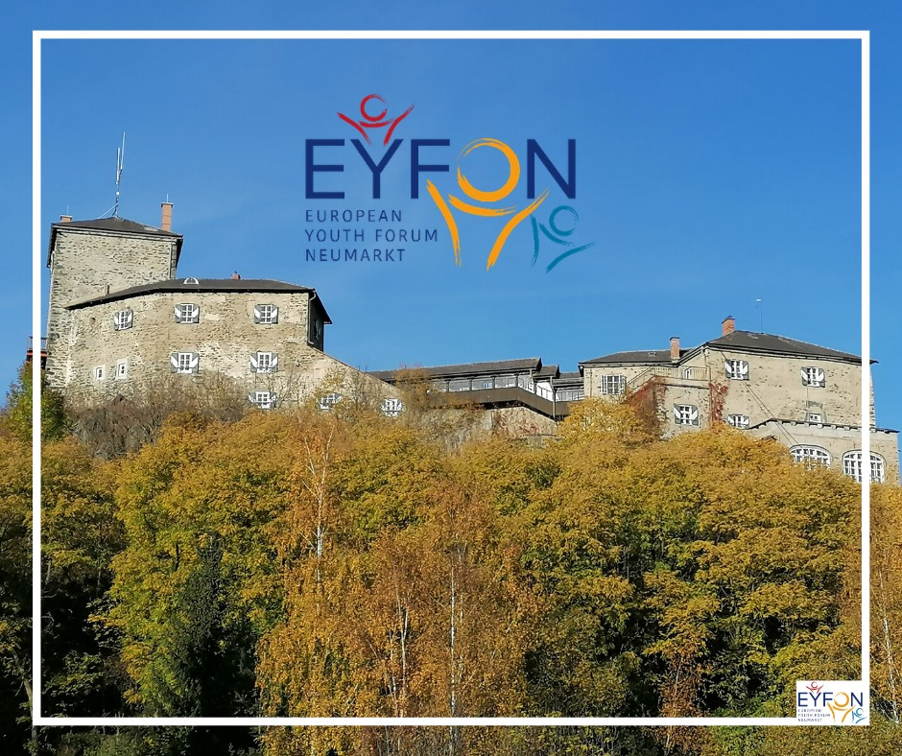

Let's delve into the future of your continent, explore your background, and foster critical thinking and perspectives for a modern Europe!
About EYFON
EYFON - European Youth Forum, a meeting and dialogue centre at Forchenstein Castle (Europaburg) in Neumarkt in der Steiermark (Region of Styria), was established in March 2018. It is located a rural area, surrounded by mountains and forest. There are connections to Klagenfurt (approx. 40 min) and Graz (approx. 1,5-2h).
EYFON collaborates with young people/groups from all over Europe, providing a space for the promotion of European values and principles. A key motivation was to seek answers to the challenges currently faced by Europe. We organize weekly seminars where young Europeans discuss the future of the European continent, pose critical questions, and develop perspectives on how to strengthen European citizenship. In partnership with relevant European institutions, we offer an exciting and inspiring program for young people centred around European ideas and ideals. Our focus extends beyond the apparent question of individual nationality versus the European Community; it also includes topics such as tolerance within different regions of Europe, specific cultural characteristics, and diverse approaches to issues like migration. Professional talks, presentations, and workshops are interspersed with enjoyable social activities, cultural excursions, and sports events.
Young people between 14 and 29 are crucial in the context of current and forthcoming political changes – it is about your future, your expectations, and your outlook on life. We want you to fully leverage the potential and countless possibilities of the digital age, internationalization, and migration while recognizing and mitigating any potential risks and dangers. To achieve this goal, a united Europe is essential.
The European Youth Forum Neumarkt contributes to the inter-European dialogue by providing a platform for young people to meet, exchange thoughts and ideas. Experience the spirit of the European community firsthand and find answers to the question: What will Europe's future look like?

Role of EYFON Volunteers
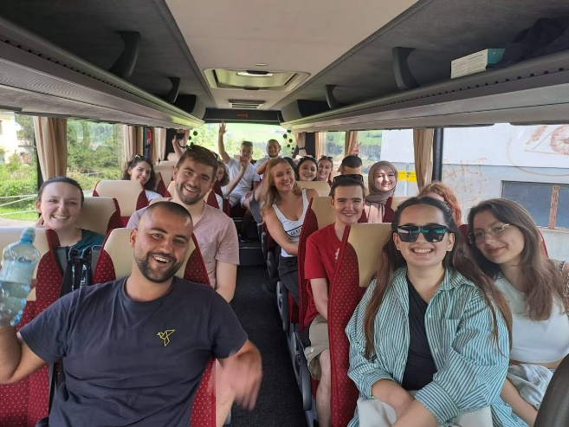
The volunteers support organizing events in EYFON, such as conferences, workshops, and summer camps. They assist in accompanying groups on excursions and free-time activities. They inform about the rules in the castle. They also help in the office, take care of social media, and participate in other publishing activities.

Profile of the Tasks
1. Photography, Videography & Digital Communication
Are you creative, enjoy working with photos and videos, and want to tell stories about Europe and young people? This position is for you!
Your tasks include:
- Taking photos and videos during EYFON events, workshops and international youth encounters.
- Creating social media content, including Instagram posts, stories, reels and short videos. https://www.instagram.com/eyfon.at/
- Editing photos and videos and turning them into engaging digital content.
- Conducting interviews with participants, speakers and project partners.
- Supporting the management and regular updating of the EYFON website.
- Writing articles, event reports and stories for the EYFON website and Newsletter.
- Documenting our activities and helping share the experiences of young people with a wider audience.
- Contributing your own creative ideas to improve our digital communication and online presence.
You will gain experience in: photography, videography, content creation, digital storytelling, website management and communication in an international NGO.
Previous experience is welcome but not essential. Motivation, creativity and a willingness to learn are what matter most.
2. Youth Engagement & Event Support
Do you enjoy meeting new people, bringing people together and making everyone feel welcome? Do you like organising activities and helping others feel part of a group? Then this position might be the right fit for you!
Your tasks include:
- Preparing and facilitating getting-to-know-each-other games, icebreakers and team-building activities.
- Helping participants connect, build friendships and feel comfortable in an international group.
- Supporting participants throughout their stay at Europaburg Neumarkt.
- Assisting with the practical organisation and smooth running of workshops, seminars and youth encounters.
- Preparing coffee breaks and helping with catering and other daily event activities.
- Supporting group activities, intercultural evenings and leisure programmes.
- Helping create a welcoming, inclusive and friendly atmosphere for participants from different cultural backgrounds.
- Contributing ideas for interactive activities, informal learning and community building.
You will gain experience in: youth work, non-formal education, intercultural communication, group facilitation, event support and international teamwork.
You do not need to be an experienced youth worker. Being approachable, reliable, open-minded and interested in working with people is more important.

3. Technical Support, Gardening & Outdoor Activities
Do you enjoy working with your hands, being outdoors and seeing the results of your work? Are you interested in practical maintenance, gardening and caring for nature? This position combines technical support with outdoor projects at Europaburg Neumarkt.
Your tasks include:
- Supporting our caretaker with general maintenance, minor repairs and practical tasks around the castle.
- Helping maintain the buildings, equipment and outdoor facilities.
- Taking care of the green spaces in the castle courtyard, including flower beds and areas where we grow edible plants.
- Planting, watering, pruning and maintaining flowers, herbs, vegetables and other plants.
- Helping improve and develop outdoor areas around the castle.
- Contributing to the maintenance and care of the surrounding woodland and natural areas.
- Supporting practical outdoor activities and developing ideas to make our green spaces more attractive and sustainable.
- Helping prepare outdoor areas for events and activities with international youth groups.
- Contributing to a pleasant, functional and environmentally conscious environment for participants, staff and visitors.
You will gain experience in: practical maintenance, gardening, sustainable outdoor management, teamwork and hands-on project work in a historic castle environment.
No professional gardening or technical experience is required. You should, however, enjoy practical work, be willing to learn and feel comfortable spending time outdoors in different weather conditions. Technical tasks will be carried out with appropriate guidance and supervision.
What all three positions have in common
Regardless of your chosen position, you will become part of the EYFON team and contribute to our international educational programmes.
You will have the opportunity to:
- Meet young people from across Europe and beyond.
- Support programmes focusing on European cooperation, democracy, peace education, media literacy and intercultural understanding.
- Participate in the preparation and implementation of international events.
- Develop your language, communication and teamwork skills.
- Take initiative, share your ideas and develop your own small projects.
- Experience life in Austria and discover the surrounding region.
- Learn about the work of a European youth organisation and contribute to its daily activities.
Our volunteering programme is designed as a learning experience. You do not need to know everything from the beginning: we will introduce you to your responsibilities, support you throughout your stay and encourage you to develop your skills and take on new challenges.
Who are we looking for?
We are looking for three volunteers who:
- Are interested in European youth work and intercultural exchange.
- Are motivated to contribute to the daily life of our organisation.
- Enjoy working in an international team.
- Are open to learning new skills and taking initiative.
- Are reliable, flexible and willing to support different activities when needed.
- Are excited to spend an extended period in a rural part of Austria.
The ideal duration is 12 months, allowing you develop your skills and take responsibility for your own tasks and projects.If you are looking for a meaningful volunteering experience where you can contribute, learn and meet people from across Europe, we would love to hear from you!
Volunteer Benefits: Proper accommodation in Neumarkt is provided; volunteers will live in a flat. Self-allowance for food and pocket money follows program guidelines.
Training and Support: Volunteers will participate in On-Arrival and Mid-Term Training organized by the National Agency. They will have access to the Online Language Support Tool. The organization provides task-related support, supervision, and guidance through experienced staff. We use state of the art tools that also private-sector companies use – during your volunteering you will learn how to use this tools (example: Atlassian Jira & Confluence, BREVO, Canva)
Volunteer’s Experience
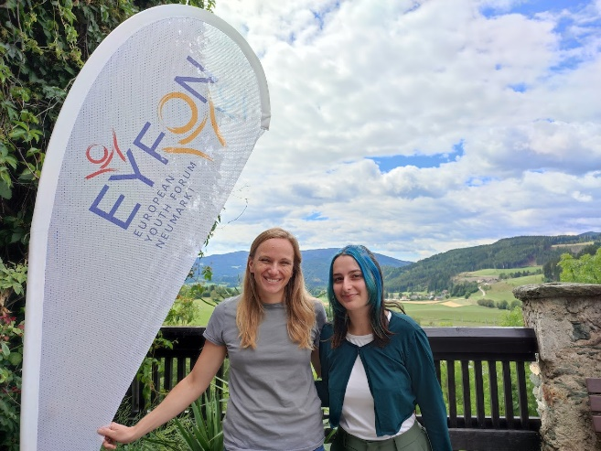
„The decision to leave my country for three months and embark on this wonderful journey was a little spontaneous. Totally changing my everyday life (with no idea what it's going to be like) is scary, but certainly the most exciting thing I've experienced so far. My goal was to enjoy the small things I would achieve and the friendships I would make; to let go of the fear of the future and to unfold completely in the present.
I remember before taking a plane how surreal this opportunity seemed. This is how I feel now, as the project is already finished. Castle Europaburg really has become a special place for me and all the participants who have been there. The most amazing part of the project was getting to know so many different people. Looking back at the first event in which I took part, I hardly can find words to express the feelings that I experienced. Europaburg castle, filled with participants from different countries sharing the same view about Europe, is the purpose of EYFON.
Discussions, getting to know each other and foreign cultures, and learning how to live in peace, even though there are many significant differences, are what our projects stand for. For many people, understanding the term "European" does not come naturally. That is why EYFON aims to spread information about the EU and the importance of the unity of Europe”.
EYFON has hosted a trainee in previous ESC program. Here is a video about this project from 2019: https://www.youtube.com/watch?v=XBj2ei-STLY
note: Kathrin Traumüller from the Video does not work at EYFON anymore.

EYFON 2026:
From Left to Right : Günter House Technician, Nina ESC Volunteer, (Dog, Tobi, still a puppy), Chiara ESC Volunteer, Dave Projectmanager EYFON.
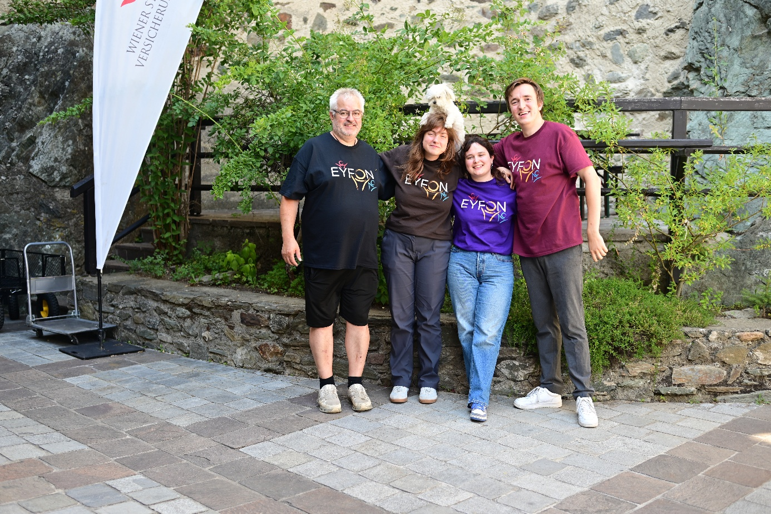
--
Lead Organisation: LOGO jugendmanagement gmbh, Graz, Austria
Website: www.logo.at/esc
Contact: esc@logo.at

